E-Waste Recovery Process: Hydrometallurgy
Complete process description for metal recovery from e-waste
Assignment component 1. The selected recovery route is hydrometallurgy. It uses aqueous chemical solutions to dissolve selected metals from prepared e-waste and then separates and recovers those metals from the solution.

1. Objective
- Recover valuable metals from the metal-rich fraction of e-waste.
- Use controlled aqueous leaching followed by purification and metal recovery.
- Reduce the amount of valuable material sent to disposal while keeping hazardous residues under controlled management.

2. Overall process
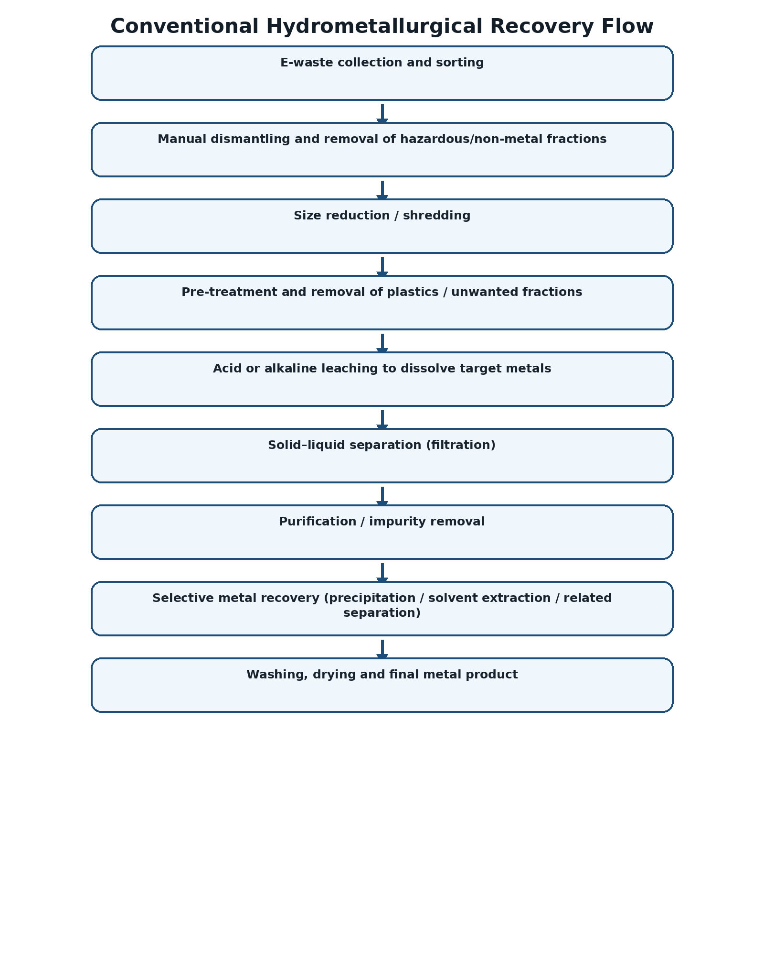

3. Step-by-step description
Collection and sorting: E-waste is collected and separated into useful streams such as printed circuit boards, cables and other metal-rich components. Batteries and hazardous components should be segregated.
Dismantling: Components are dismantled to expose metal-bearing parts and remove plastics, casings and other unwanted fractions.
Size reduction: The selected metal-rich fraction is shredded or milled to increase surface area and improve contact with the leaching solution.
Pre-treatment: Physical separation and suitable pre-treatment reduce plastics and other non-target materials before chemical processing.
Leaching: The prepared material is contacted with a suitable aqueous leaching system. The target metals dissolve into the liquid phase.
Solid–liquid separation: The metal-bearing solution is separated from the remaining solid residue by filtration or equivalent separation.
Purification: Impurities are removed from the leach solution using controlled separation operations. The exact chemistry depends on the target metal and feed composition.
Selective recovery: The desired metal is recovered from the purified solution, commonly by controlled precipitation or another selective separation route.
Washing and drying: The recovered solid is washed and dried to obtain a cleaner metal-bearing product. Residues and spent solutions are handled safely.

4. Metals that can be targeted
- Copper (Cu) – commonly present in printed circuit boards, wires and connectors.
- Gold (Au) – present in small quantities in contacts and connector coatings.
- Silver (Ag) – present in contacts and electronic components.
- Nickel (Ni), zinc (Zn), cobalt (Co) and other metals – depending on the e-waste feed.
- Lead (Pb) and other hazardous metals require controlled handling rather than uncontrolled recovery.

5. Advantages
- Can be selective when the leaching and recovery chemistry is properly controlled.
- Usually operates at lower temperatures than pyrometallurgical processing.
- Can achieve high metal recovery from suitable, well-prepared feeds.
- The process can be adapted to recover different metals sequentially.

6. Limitations / safety considerations
- Chemical consumption and wastewater treatment can be significant.
- Leaching solutions must be contained and treated before discharge or reuse.
- Mixed e-waste composition can make process control difficult.
- Hazardous components and residues must be managed according to applicable regulations.

7. Key output
A purified metal-bearing product is obtained after leaching, purification and selective recovery, while the remaining solid/liquid residues require controlled treatment.

